|  |  |
| --- | --- |
| Ex No: 3 | **USE CASE DIAGRAM** |
| Date: 26/07/2001 |

**AIM:**

Use Case Diagram for the project: E-Learning System.

Use case diagram is to identify the functionality provided by the system (use cases), The user who interact with the system (actors), and the association between the users and the functionality. Use cases are used in the Analysis phase of the software development to articulate the high-level requirements of the system. The primary goals of Use case diagrams include:

* Providing a high-level view of what the system does.
* Identify the users (actors) of the system
* Determining areas needing human-computer interface.

Use case extend beyond pictorial diagrams. In fact, text-based use case descriptions are often used to supplement diagrams and explore use case functionality in detail.

**DESCRIPTION:**

The basic components of Use case diagrams are the Actor, the Use case, and the Association.

**Actor:**

An Actor, as mentioned, in a user of the system, and is depicted using a stick figure. The role of the user is written beneath the icon. Actors are not limited to users. If a system communicates with another application and expects input or delivers output, then that application can also be considered an actor.

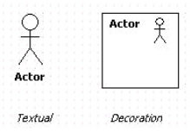

**Use Case:**

A Use case is a functionality provided by the system, typically described as verb + object (e.g.: Register Car, Delete User). Use cases are depicted with an ellipse. The name of the use case is written within the ellipse.

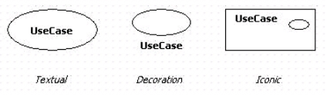

**Association:**

Associations are used to link Actors with Use Cases and indicate that an Actor participates in the Use case in some form. A line connecting the Actor and Use case depicts associations.

The following image shows how these three basic elements work together to form a use case diagram.

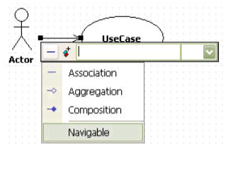

**ALGORITHM:**

Step 1: Define the actors like students, Instructor and Admin panel organizer for the E-Learning System.

Step 2: Determine the events that are necessary for developing a system.

Step 3: Represent the communication relationship of an actor in the system by connecting the actor symbol to the Use-Case symbol with a solid path.

Step 4: Represent the ‘Uses’ and ‘Extends’ relationship if required.

Step 5: Use the necessary tools for developing the E-Learning System .

**OUTPUT:**

**SPECIFICATION:**

The above use case diagram is for the project E-Learning System. This E-Learning system contains 3 actors of Instructors, Students and Admin panel organizer. Instructor associated with Login page, course uploading page and payment receiving page. Students associated with Login page, Course Enrolment and buying courses. And the third actor is the admin panel organizer to organize all the backend stuffs.

**RESULT:**

The Use cases are used in the Analysis phase of software development to articulate the high-level requirements of the system are drawn successfully.